Managing IT Resources

ITWS 4310

Fall 2018

Week 6 Assignments

1. Monday October 1, 2018
   1. Read Chapter 13, *Understanding Software: A Primer for Managers*, in the Gallaugher text.
   2. Read Chapter 14, *Software in Flux: Open Source, Cloud, Virtualized, and App-Driven Shifts,* in the Gallaugher text.
   3. Read the Current Event Articles posted on LMS
   4. **In-class Exercise**: Be prepared to discuss in class how you would characterize your team’s Term Project based on the following Project Architecture Diagram:

TPS: Transaction Processing System

MIS: Management Information System

SM: Social Media

BI: Business Intelligence, Analytics

AI: Artificial Intelligence

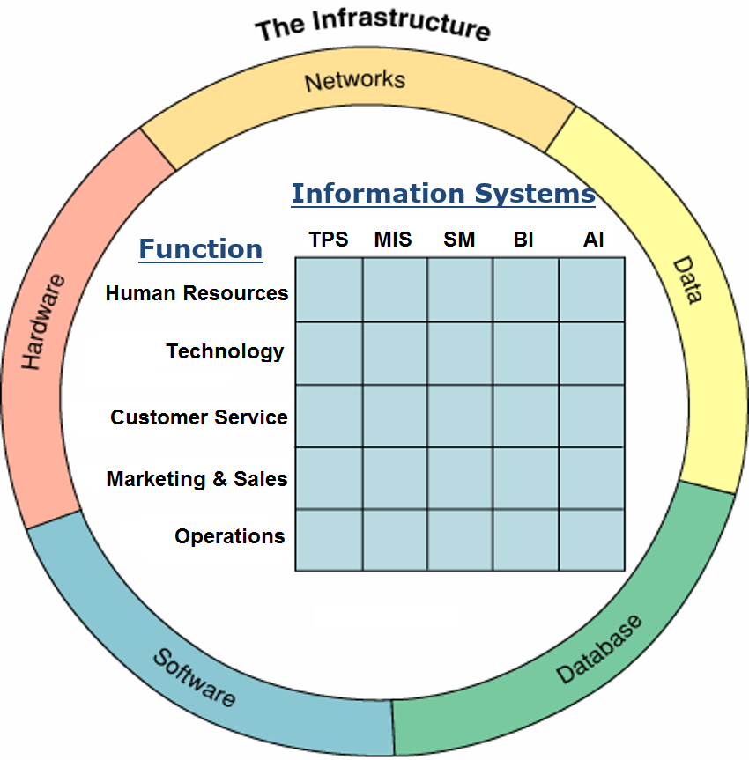

1. Thursday October 4, 2018
   1. Read Chapter 8, *Platforms, Network Effects, and Competing in a Winner-Take-All World* in the Gallaughertext.
   2. Read Chapter 16, *A Manager’s Guide to the Internet and Telecommunications* in the Gallaugher text.
2. Reminders
   1. Work on “System Requirements” with Client due as part of “Initial Sections” on Oct 9 by 9 PM
   2. Risk Management Term Project Assignment for All Teams due as part of “Initial Sections” due Tues Oct 9 by 9 PM